Monitoring Type: Formal Monitoring

Night Survey #: 2 Outing #: 1 Survey Aborted? N Survey Completed? Y % Survey Area Covered: 100

Sunrise or Sunset Time: 0550

UTMs of New or Intermediate Call Points or Routes (not already mapped):
Call point name | UTME | UTMN |  | Call point name | UTME | UTMN
Moon phase: 2/4
TIME (24hrs) | Start | End | Total (~ ¼ hr)
Hike-in | 0403 | 0411 | 0.25
Survey | 0411 | 0539 | 1.50
Hike-out | 0539 | 0620 | 0.75
CP or RT # | CM | SM | Time Start | Time End | Total Time | Moon visible | Wind (mph) | CC % | PPT | Temp (◦F) | Obs. Type | Sex | Age | SPP | Time of response | Bearing  (◦) | Distance (m) | UTM E  of owl  (estimated) | UTM N  of owl  (estimated)
IdaCyn1 | 2 | 2 | 0411 | 0421 | 10 | N | 0-5 | 0 | N | 41 | N
IdaCyn2 | 2 | 2 | 0429 | 0439 | 10 | N | 8-12 | 0 | N | 41 | N
IdaCyn3 | 2 | 2 | 0448 | 0458 | 10 | N | 5-8 | 0 | N | 40 | N
IdaCyn4 | 2 | 2 | 0510 | 0520 | 10 | N | 0-5 | 0 | N | 38 | N
IdaCyn5 | 2 | 2 | 0529 | 0539 | 10 | N | 0-5 | 0 | N | 37 | N
CM (Call Method): 1 = tape recording, 2 = vocalization, 3= combination, 4 = owl “hooter”; SM (Survey Method): 1 = leap frog, 2 = point calling, 3=continuous calling; Wind = range in mph; CC= cloud cover, PPT= precipitation (Y or N), Temp = ambient temperature; Obs. Type = aural (A), visual (V) detection, or put (N) for no response. SPP = 4 letter species code based on Latin name; Mex. Spotted Owl = STOC; Great Horned Owl = BUVI; Long-eared Owl = ASOT; Flammulated Owl = OTFL; Whiskered Screech Owl = OTTR; Western Screech Owl = OTKE; Elf Owl = MIWH; Northern Pygmy Owl = GLGN.

Brief Notes
Comments:
I left my vehicle on the road near D’Albini Ranch at location UTM (NAD83): 563725E, 3471827N and began hiking at 0403 (see Start/End and blue route on map). . This canyon offers plenty of suitable MSO habitats. The recent wildfire didn’t seem to affect this canyon at all. Calling conditions were optimal around sunrise near the historical MSO location.
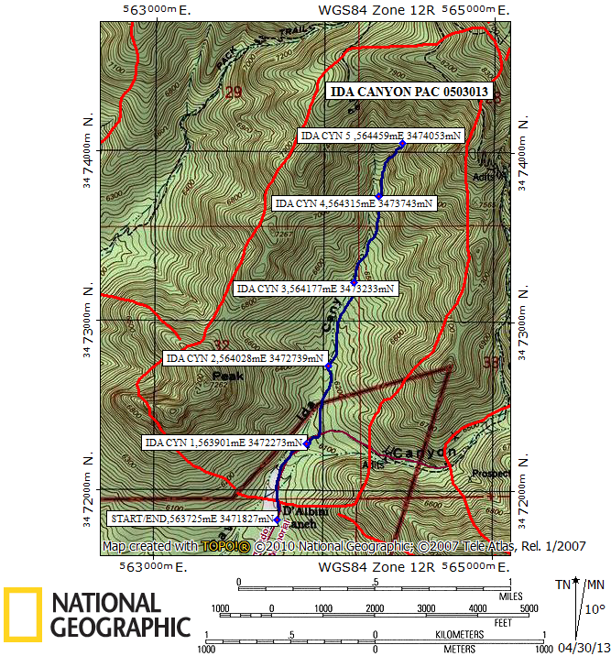

Red line = PAC boundary Blue line = path hiked

